Name : Abdul Samad
Program: BSSE Group A
Semester: 5th

Predicted Output:
- For first output the price will be changes as in python we have everything by address so now the price will be unchanged
- IT will be printing BuG original cart modified as in python when one list is equalled to another list so they point to the same address. That’s why changing by one will change another as well.
- Now when we make a copy of a list so that means that there is another copy is created for it so it will like different cart objects

Actual Output:
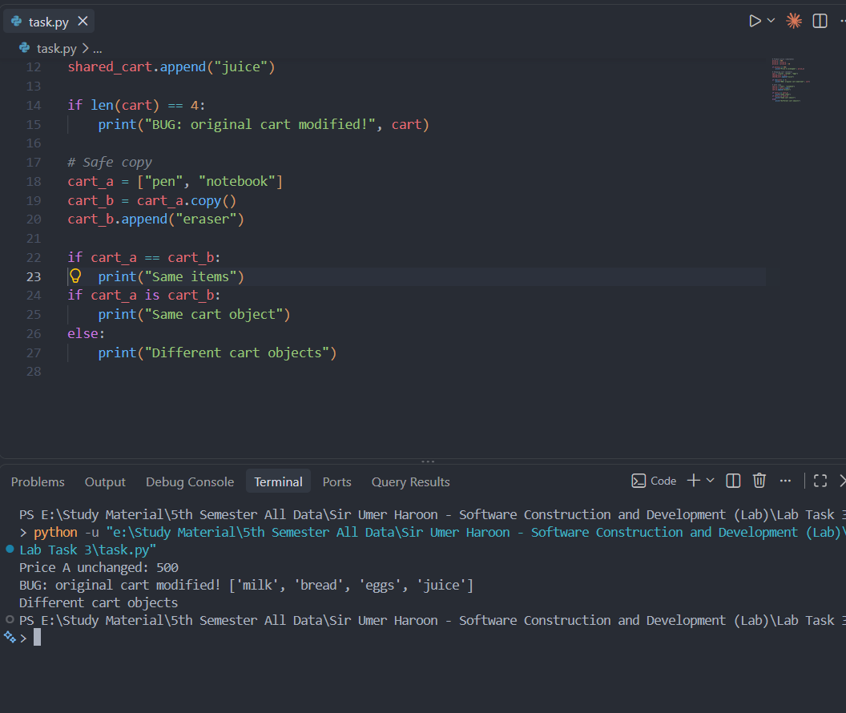

I got my two points correct but I made it wrong the first one.

Corrected Code:
